DAT 530 Final Project Milestone Four: Interactive Dashboard

Michael Surdek

Southern New Hampshire University

The following is an interactive dashboard intended for analysts of the Emergency Management Agency who wish to analyze real-time severe weather event data. The focus of this dashboard is to explore deaths and injuries caused by severe weather events across various types of events, months, and locations.

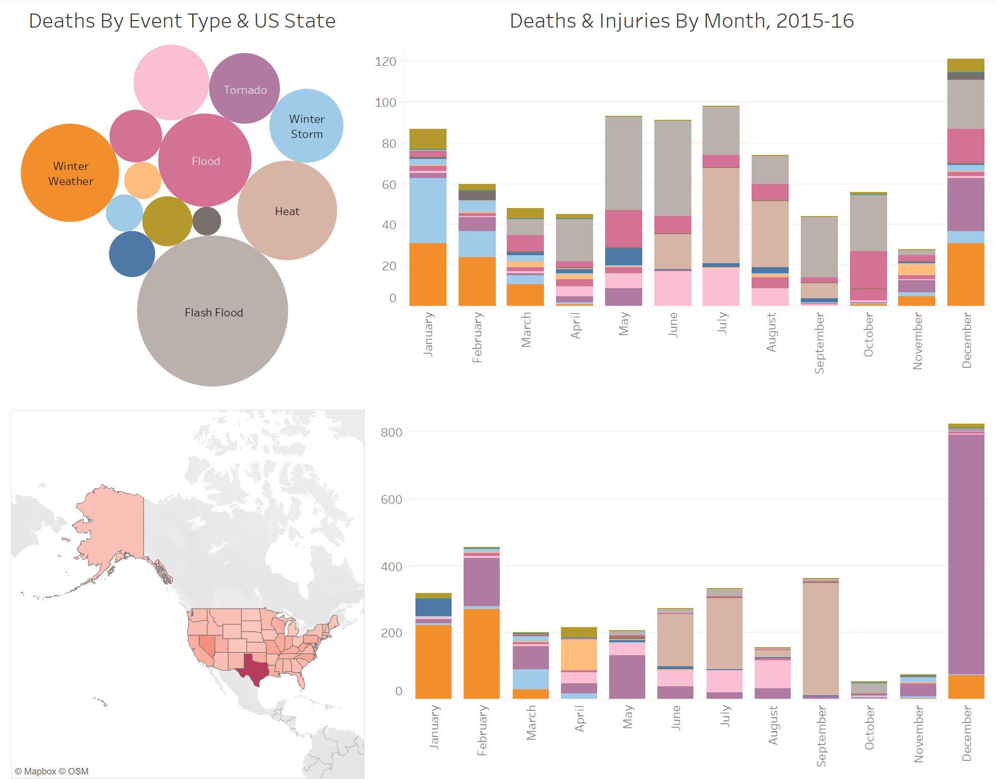

Right away it is possible to make comparisons between deaths and injuries. For example, why does heat cause so many more injuries in September than it causes deaths? Maybe it has something to do with schools being open and high school sports starting up. This is something the analysts could look into further.

The best way to interact with the dashboard and find even more questions to explore is by using the dashboard’s interactive capabilities and filtering categories. There are 3 ways main ways to filter the dashboard, and many more when you include combinations.

1) Filter by event type; this allows you to focus on an event type and see how it causes deaths and injuries based on month or location.

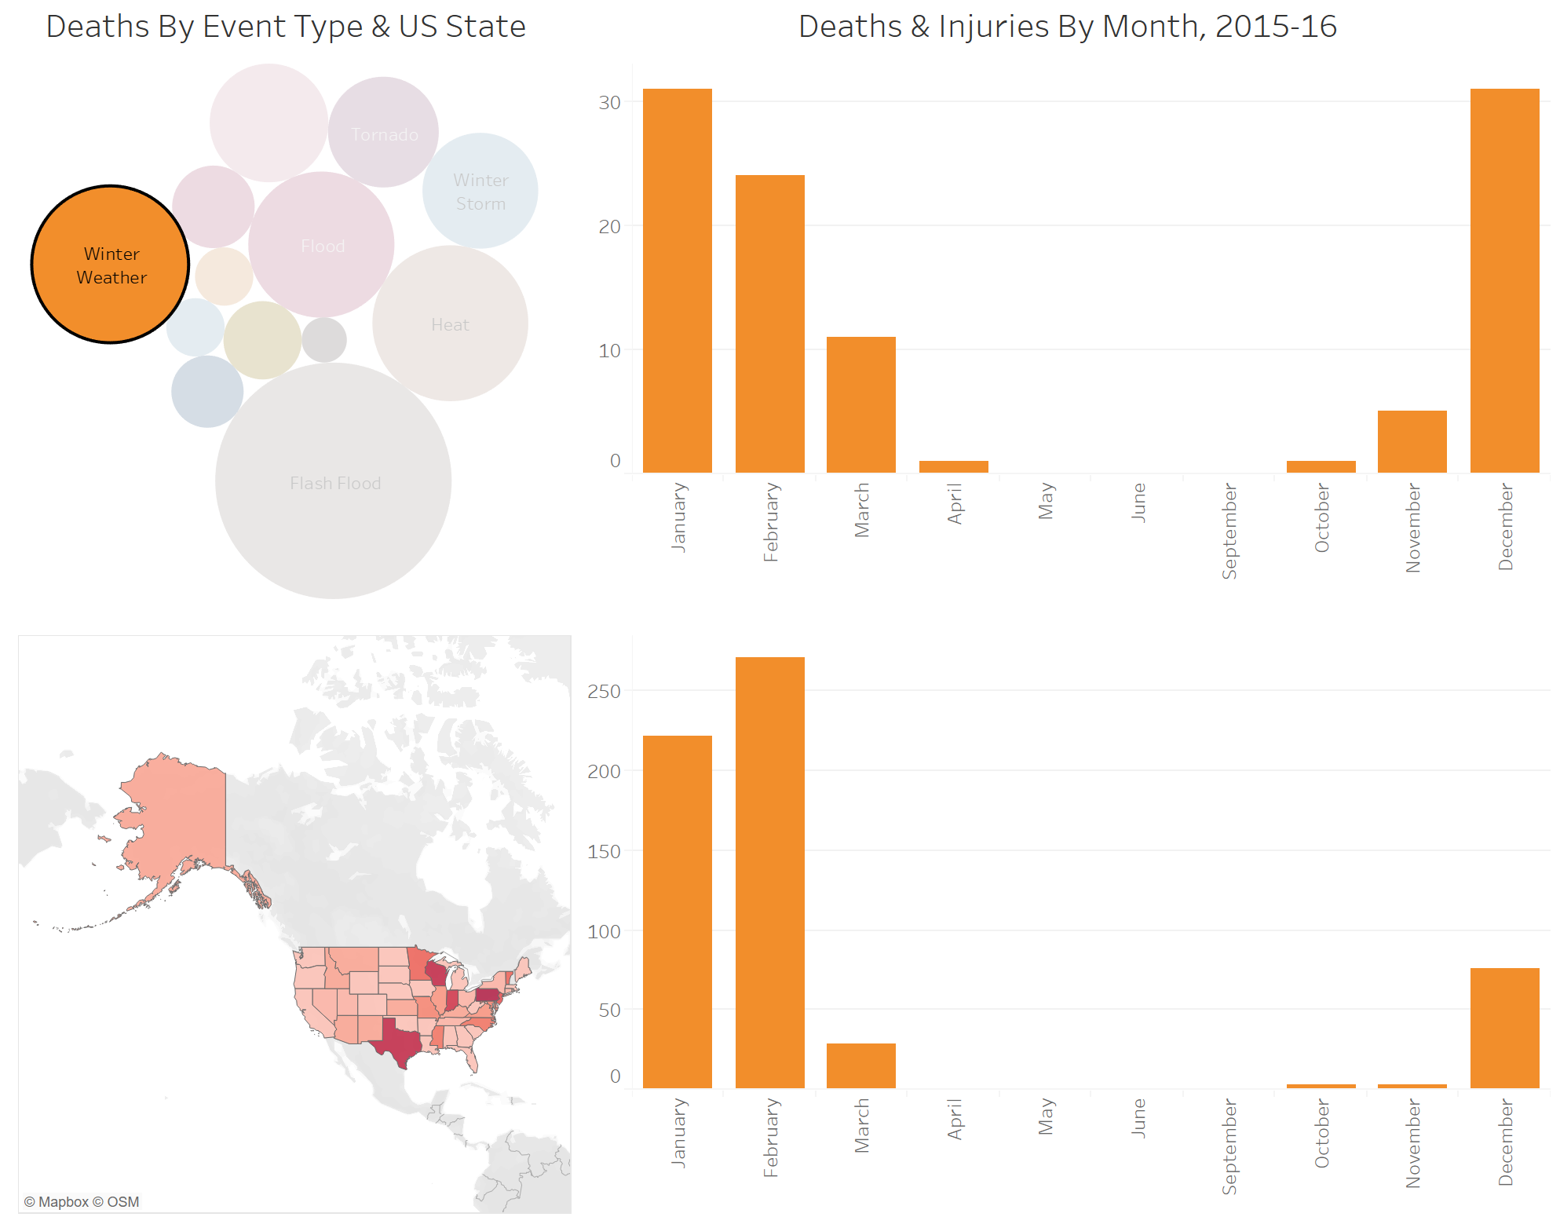

2) Filter by state; this allows you to focus on one state and see what weather events cause the most deaths and injuries in that state and in which months.

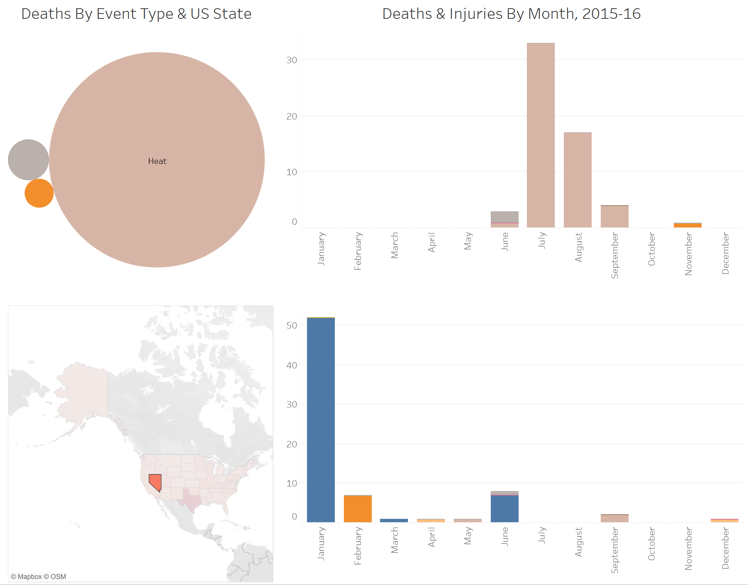

3) Filter by month; this allows you to focus on a month and see what weather events cause the most deaths and injuries in that month and in which states.

